Civil Rights Movement Name: ________________________
Learning Intentions | Success Criteria
To identify and explore Indigenous rights and freedoms throughout Australian history. | I can identify and discuss Indigenous rights and freedoms throughout Australian history.
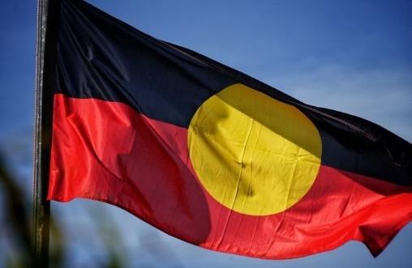
Key questions:
- How have Indigenous peoples in Australia struggled for rights and freedoms?

INDIGENOUS RIGHTS NOTES
British Settlement
- When British explorers and settlers arrived on the east coast of Australia in ________, they did not understand the Indigenous population.
- They proclaimed Australia terra nullius – a Latin term that literally translates as ‘______________ _______________’.
The negative effects of European settlement on Indigenous Australians
- The expansion of British colonial settlements into established Aboriginal lands destroyed _________________ ways of life.
- High numbers of Indigenous Australian premature ____________ were the result of violence and disease.
- By the time of Federation in 1901, European settlements dominated most of the continent. Aboriginal and Torres Strait Islander cultures were not ______________ ________________.
- Public policy was dominated by ideas of ______________ (separating blacks from whites) and _______________ (integrating blacks into white society).
- Both ideas were based on the assumption that Aboriginal people were _____________ to Europeans.

Assimilation Policy
- Officially adopted in ______________.
- Aboriginal people of mixed race were to be _________________ into white society whether they wanted to be or not.
- If these people were not going to simply ‘die out’ then all efforts should be directed to ensuring that mixed-race Aboriginal people could be _______________.
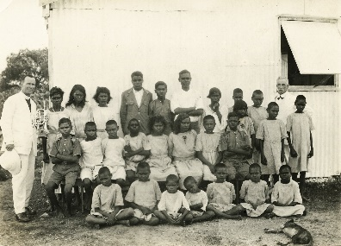
The Stolen Generations
- From the late 1800s to the 1970s many thousands of Aboriginal children were ______________ ________________ from their families and placed into state care or placed with white families.
- These children, now referred to as the ___________ _________________, faced ongoing emotional and social difficulties because of their removal from their families.
Segregation
- Another effective means of controlling Aboriginal and Torres Strait Islander people was to prevent them from ___________ _______________ in society.
- ‘____________ __________ – bans that prevented Aboriginal people from entering clubs, restaurants, public swimming pools or using public transport etc.
- Aboriginal people were ____________ from working particular jobs and expected to work for less money.
- ____________ ______________ in theatres, separate wards in hospitals, and denial of school enrolment to Aboriginal children were common.
- The practice of segregation continued until the __________.
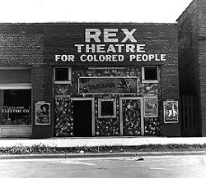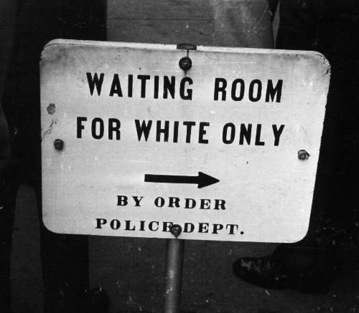
Indigenous protests during the 19th and 20th centuries
- Despite the many _____________________ policies of Australian colonial and state governments in the late 19th and early 20th centuries, Indigenous Australians made repeated attempts to have their traditions and rights ______________.

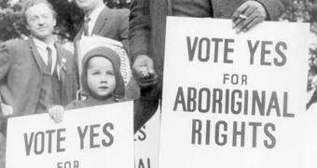
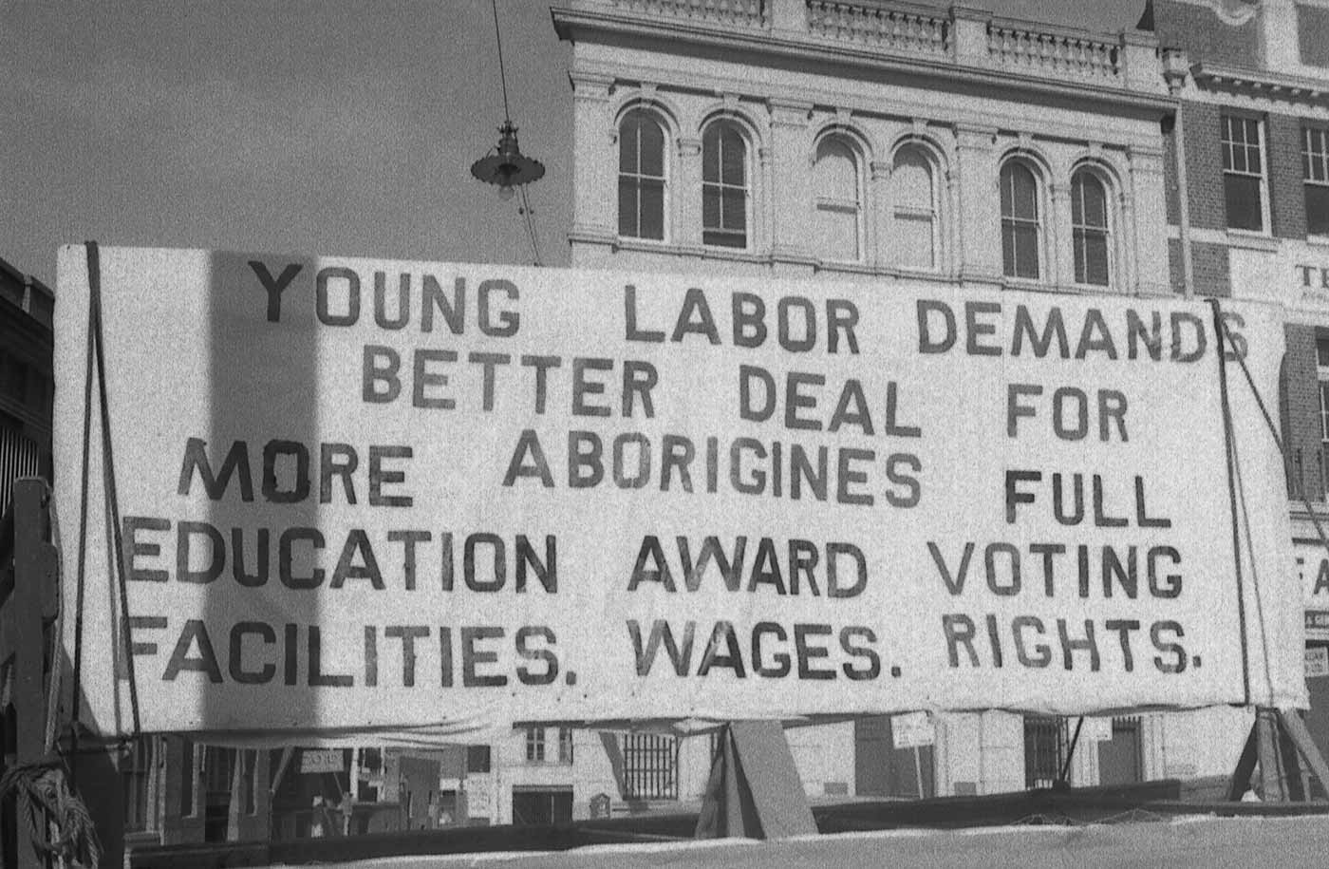

 | Success Criteria
 | I can identify and discuss Indigenous rights and freedoms throughout Australian history.

Civil Rights Movement
Learning Intentions | Success Criteria
To identify and explore The Universal Declaration of Human Rights. | I can identify and discuss The Universal Declaration of Human Rights.

Key questions:
- How have Indigenous peoples in Australia struggled for rights and freedoms?

The Universal Declaration of Human Rights NOTES
Introduction
- It was only until after Australia’s _______________ of the Universal Declaration of Human Rights in _______ that attention gradually turned towards the situation and status of Aboriginal and Torres Strait Islander peoples.
The legacy of World War II
- Millions of people were ________________ during World War II.
- Immediately after the end of World War II, the ____________ ____________ was formed and work started on formalising a set of basic human ________.
- Part of this work involved establishing a set of international _________ and _______________ to protect people.

Australia’s Role
- Australia’s Attorney-General, Herbert ‘Doc’ Evatt convinced traditional powers such as Britain and France that the ______________ ______________ must be seen to take a leading role in the development of laws to protect human rights.
- Evatt was General Secretary of the United Nations in ________ and ________, during which time he led the drafting of the ____________ Declaration of ___________ Rights.
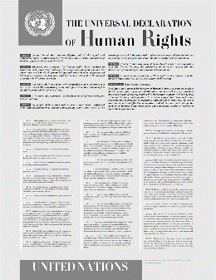
The Universal Declaration of Human Rights
- This landmark document has ____ ___________ and has informed many international and national treaties and agreements relating to __________.
- Most significantly, the declaration held that human rights are inalienable – meaning that they _________________________ from any one of us regardless of age, race, gender, religion, language or nationality
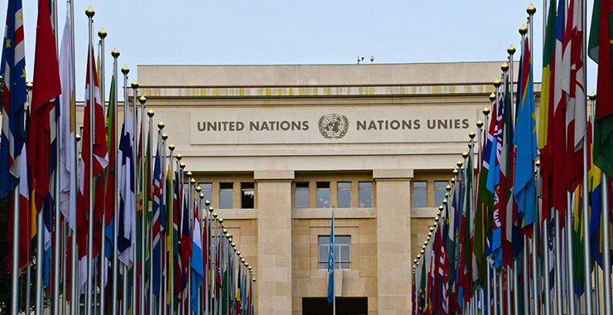
The Start of Civil Rights

Many historians argue that the Universal Declaration of Human Rights set the scene for the _____________________ that would take place around the world in the coming decades.

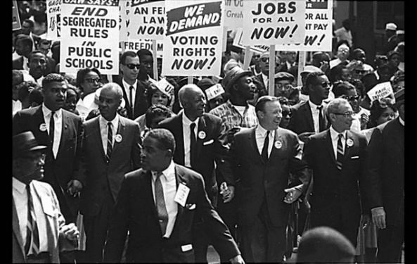
Key question:

- How have African Americans and Indigenous peoples in Australia achieved change?
The US Civil Rights Movement NOTES
During the 1960s, the struggle for civil rights for African Americans gained worldwide attention. A series of ____________ and ________________ individuals in the US civil rights movement would go on to inspire and influence civil rights campaigners in Australia. We will now explore some of these key events.
Segregation in America
- In the southern states, segregation of the races had been legally enforced since the American Civil War ended in ___________.
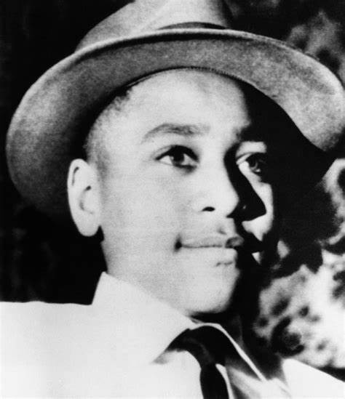
The Case of Emmett Till
- In August __________, a 14-year-old African-American boy called Emmett Till was murdered near the town of Money in ______________.
- He had been brutally beaten and shot after being accused of flirting with a white woman.
- His body was ______________ in the Tallahatchie River.
- The _____________ men accused of his murder were found not guilty in a trial conducted before an all-white ___________ in Mississippi.
- The death of Emmett Till became a ___________ ____________ ____________ for the civil rights movement.
- The 1957 _________ ____________ __________ came from the momentum generated by the Emmett Till case.
1957 Civil Rights Act
The Act aimed to ensure that all African Americans could exercise their right to _________, as well as providing resources for ongoing monitoring of civil rights abuses. It also called for a government ___________ on race relations.
Boycotts
At roughly the same time, African Americans across the country began to assert their _____________ for equality in a number of different ways.

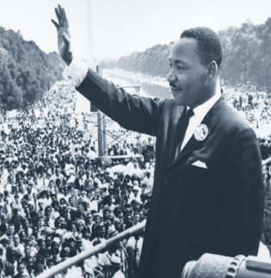
Martin Luther King Jr.
- In 1963, King led the March on _______________, which was attended by 250000 people, many of whom demanded an end to segregation.
- King redefined the rights movement.
- While the US Supreme Court had delivered a legal plan for desegregation, King’s famous ‘I have a dream’ ____________ delivered at the March on Washington was a moral plan for change.
On 2 July 1964, the US Congress enacted the Civil Rights Act, which outlawed discrimination based on race or gender.
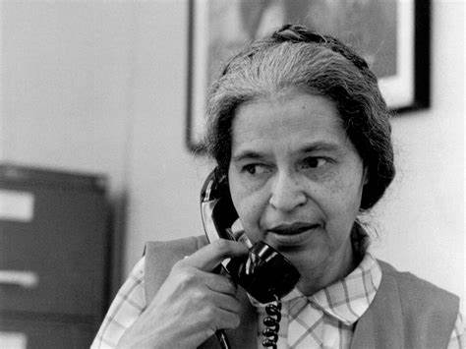
Rosa Parks
In 1955, Rosa Parks was arrested in Montgomery, Alabama, after ____________ to give up her seat at the front of a bus for a ___________ passenger. The arrest resulted in a boycott of the ___________ ______ ___________ by African-American passengers, beginning in December 1955.

